Overall Goals
HIGHLIGHT the positive features & HIDE the negative features
I use colour tricks to influence what buyers immediately notice and what they don’t. One of the ways to do this is through the use of contrast.
- When we add sharp contrast (ex: black and white), it draws the eye and calls attention. So this is a good technique for the features we want to highlight
- When we eliminate contrast (ex: black on black) it allows the eye to flow and move around the room to the focal points. So this is a good technique for when we want to hide something negative.
It may be that the design suggestions do not fit your own personal style; that’s very common. The suggestions are based entirely on how to make your home look updated and stylish with what you have to work with.
Black Tile Floor
The black tile floor is dating the house and making it feel old. Unless you tell me otherwise, I’m going to assume that you don’t want to rip the tile floor out. It is critical that we get buyers LOOKING PAST the floor in both the Kitchen and the Hallway.
Kitchen
The kitchen is the most important room to buyers. If you don’t want them to deduct 50k off your asking price to compensate for a full renovation, it must present as updated, stylish and inviting.
Black is one of the most challenging colours because to hide it, you need to add more of it. I want to do this in a softer way, by adding dark taupe-grey to the base cabinets. This will give the cabinets an updated look that is very luxurious, and also reduces the line between the floor and cabinets. This will allow us to draw buyers’ attention to other features, like a beautiful backsplash and lighting.
Hallway
There are 2 things that need to be done to update your look. A) Reduce contrast on your floor. B) Introduce contrast on your millwork. I would suggest removing all the cream carpets and replace with black ebony wood, like you have in the dining room. This will eliminate all contrast across the floors and make it look seamless. If at all possible, also change the white transition strip to black marble, so that there is zero contrast.
I suggest adding contrast to your millwork to create stronger focal points (and take the eye away from the floor). I would like to see the doors painted the same taupe-grey as the kitchen cabinets. Trimmed in white moulding, the eye will be drawn to them immediately. Second, the pickle-wash of the staircase feels very 1984, and staircases are a headache buyers don’t want to deal with. By painting the spindles & risers white, and re-staining the handrail & treads ebony, we will achieve an updated, elegant & appealing look that is very popular with buyers.
Examples: Kitchen
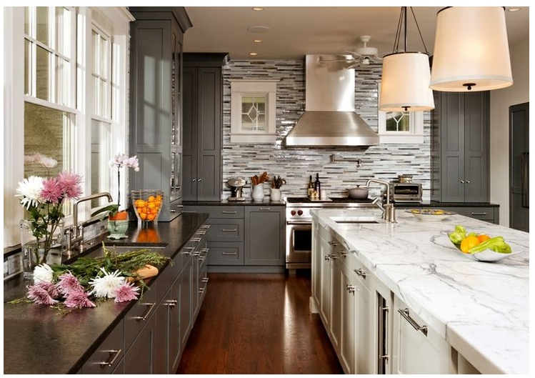
I suggest a dark granite counter to hide your cook top and add a silver hood above. I would like to see a full wall of delicate mosaic tiles on your window wall by the sink, and carried around the backsplash. Paint the uppers & tall cabs creamy white: the contrast will draw the eye up to the backsplash and cabinets.
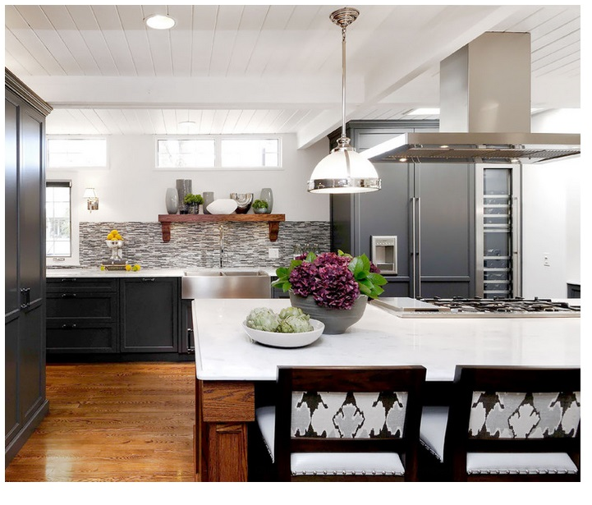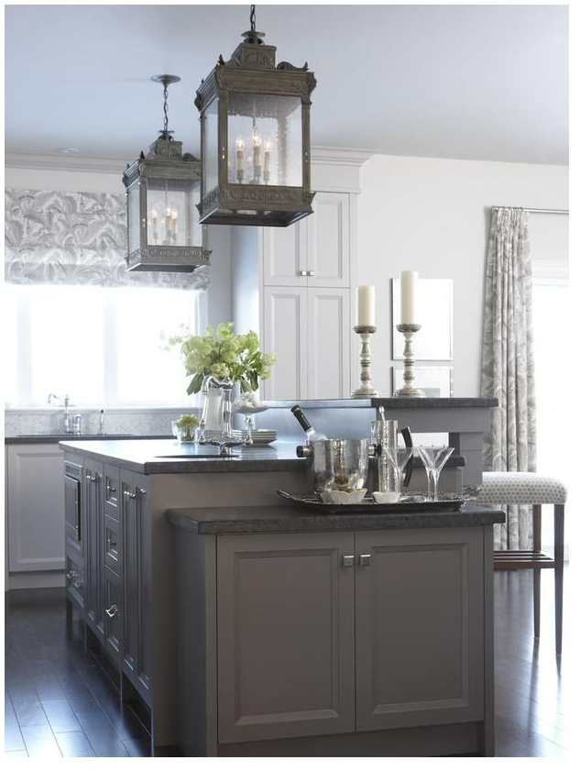
Examples: Hallway
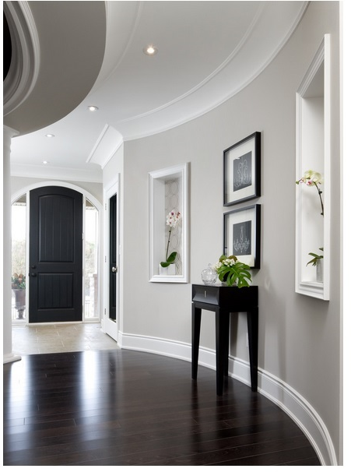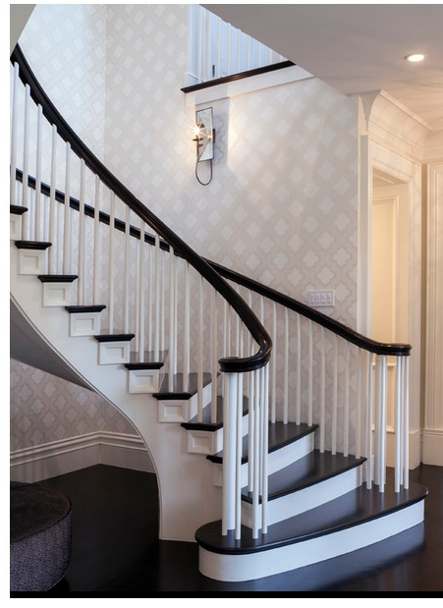
Both the staircase and the floor are making your home feel dated. By updating the carpet to wood and removing the pickle wash from the staircase, your home will feel elegant and updated. This is what buyers are looking for, and will pay good money for it.


